**CUSTOMER CHURN ANALYSIS**

**For Telco Industry Growth**

**INTRODUCTION**

In today's fiercely competitive telecommunications industry, understanding customer behavior is vital for business success. One crucial metric, customer churn—representing the rate at which customers stop using a service—can have a substantial impact on a company’s financial performance. Analyzing churn data reveals valuable information that help telco companies improve customer retention and ensure long-term success. This article will provide the analysis of customer churn datasets, the insights they offer, and strategies to minimize churn.

**QUERY 1: Considering the top 5 groups with the highest**

**average monthly charges among churned customers,**

**how can personalized offers be tailored based on age,**

**gender, and contract type to potentially improve**

**customer retention rates?**

To show what are the average monthly charges of customers who has churned and what was their age, gender and what was the contract type we will use the following query,



**Findings**

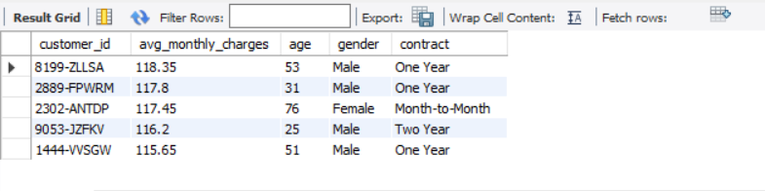

Approximately **60% of customers** who churned were **older**, suggesting age plays a role in retention. A notable number of churned customers were **male**, indicating that marketing efforts may benefit from being more targeted. Furthermore, many of these customers were on a **one-year contract**, indicating the need for better incentives to encourage contract renewals or upgrades.

**Churn Reason Analysis**

**QUERY 2: What are the feedback or complaints from**

**those churned customers?**

To find the primary reasons for customer churn;

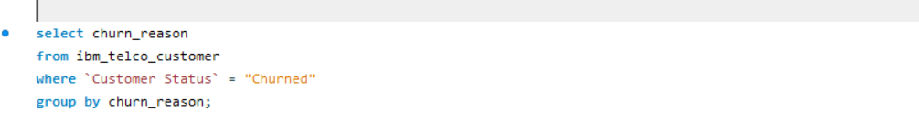

**Findings**

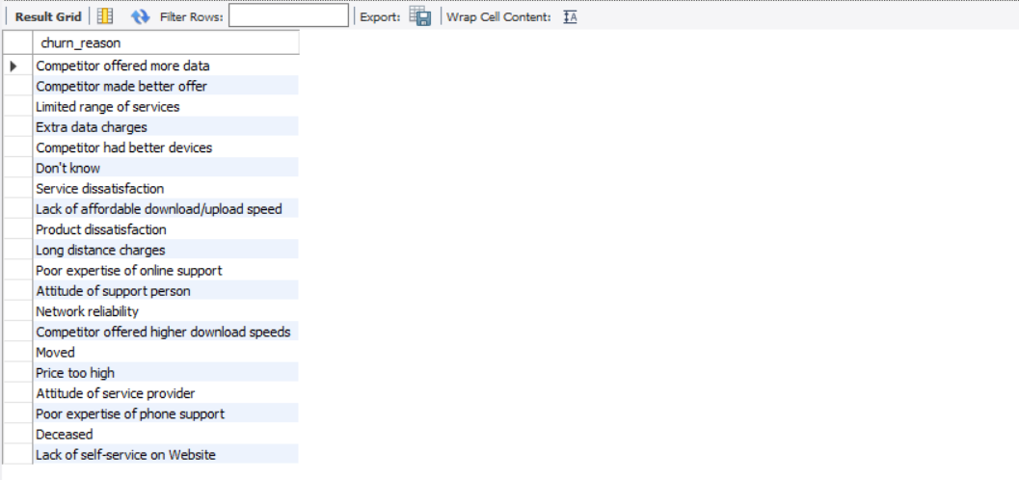

The analysis revealed that the majority of customers left due to competitors offering superior devices, highlighting the importance of product offerings. Additionally, many customers cited better offers from competitors, suggesting that offering more competitive deals could help reduce churn.

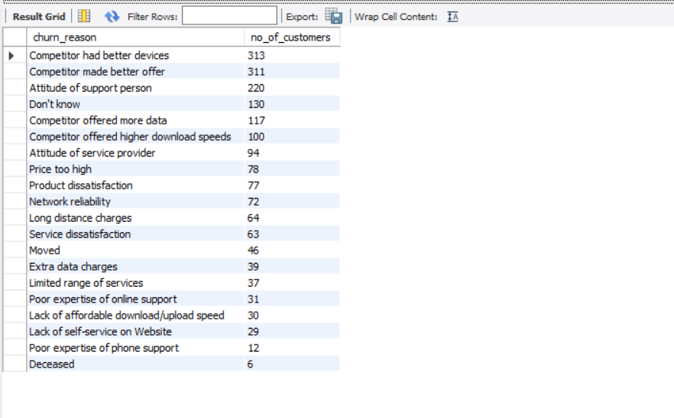

**Payment Methods Analysis**

**QUERY 3: How does the payment method influence**

**Churn behavior?**

To identify which payment methods were most frequently used by churned customers we will use;



**Result**

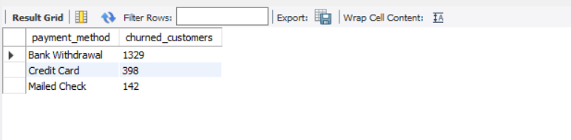

Of the churned customers, 1,329 used the bank withdrawal method, with credit card payments being the second most common method.

**Strategies to Reduce Churn**

Based on the insights gained from the analysis, telco companies can implement several strategies:

1. **Tailored Retention Campaigns**: Target customers identified as high risk of churning with personalized offers or incentives.
2. **Improve Service Quality**: Address common pain points leading to churn, such as service interruptions or customer service responsiveness.
3. **Flexible Payment Options**: To enhance customer satisfaction, consider offering more payment methods or discounts for long-term commitments.
4. **Regular Engagement**: Maintain ongoing communication with customers to keep them engaged and informed about new services or changes.

**Conclusion**

Customer churn analysis is essential for telecommunications companies striving to remain competitive. By understanding the reasons behind churn and applying targeted strategies, companies can significantly improve retention rates, boost customer satisfaction, and ensure sustained growth. Using churn analysis insights, telco companies can protect their revenue streams, cultivate loyal customer bases, and create a more sustainable future.